Tushar Iyer

G01118318

**SWE 645 HW 2**

**Part 1:**

AWS S3 URL for homepage with W3.CSS template:

<http://s3-01106606.s3-website-us-east-1.amazonaws.com/>

**Part 2:**

Docker container running Tomcat webpage in EKS:

<http://a1b99d6daf85d11e98dac0aa62a10790-688065084.us-east-2.elb.amazonaws.com/SWE_645_HW_1/>

Prerequisites for deployment:

You must have the following CLI commands installed and properly configured:

**kubectl, eksctl, aws**

(See this user guide from AWS for the installation instructions that we used: https://docs.aws.amazon.com/eks/latest/userguide/getting-started-eksctl.html)

Provision an EKS cluster:

**eksctl create cluster --alb-ingress-access**

Apply the Kubernetes deployment and service configurations:

Navigate to the directory containing the “deployment.yml” file and run the command:

**kubectl apply -f deployment.yml**

Explanation:

The deployment configuration pulls a public Docker image containing the Tomcat server and webpage, and configures the Kubernetes cluster running in EKS. The application is then reachable via the external IP that is listed when running this command to view the service info:

**kubectl get svc**

The following is a screenshot showing the output of this command for our application, to prove that it is running in Kubernetes on EKS:

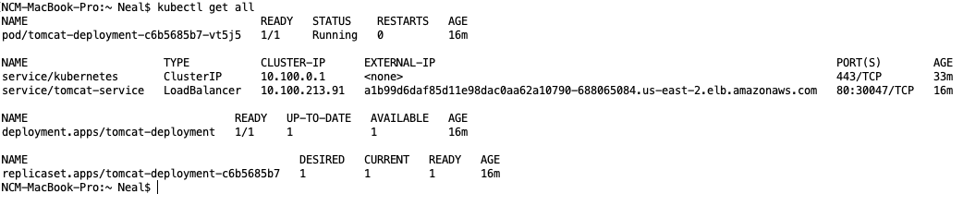

Also included is a screenshot of our AWS console showing our EKS cluster:

